How to Make Your Fruit or Nut Tree Bear-Aware
Reducing Bear Attractants Through Smart Tree Management
Why This Matters
Ripe and fallen fruit are powerful attractants for bears. Poorly managed fruit trees are one of the leading causes of human–bear conflict.
- Reduce the likelihood of attracting bears
- Protect wildlife and community safety
- Maintain a healthy and productive tree
Step 1: Manage Fruit to Reduce Attractants
- Pick all fruit early — harvest before or as it ripens
- Remove windfall fruit daily
- Do not allow fruit to accumulate
- Use the Gleaning Program if needed
Step 2: Choose Your Tree Management Goal
Maintain Fruit Production (Safely):
- Keep trees small and manageable
- Ensure all fruit can be harvested
Reduce Fruit Production:
- Use early summer pruning
- Knock off blossoms in spring
Step 3: Prune Properly
- Never remove more than 25% of the tree
- Aim for an open-centre shape
- Maintain branches with wide angles (>45°)

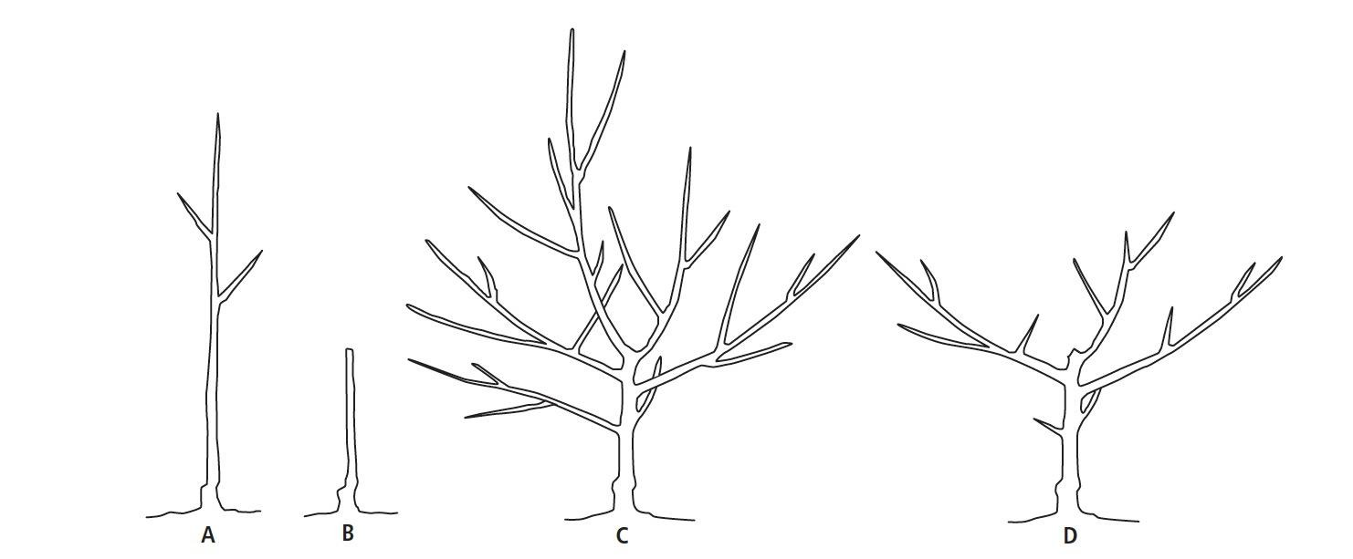
Open centre pruning method. (A) Tree at planting. (B) Tree headed for planting. (C) Growth after one season. (D) Tree pruned after one growing season.

Timing:
- Early summer pruning reduces the size and fruit
- Late winter pruning increases growth
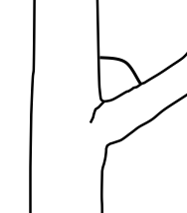
Figure 2. Choose branches with a greater than 45° angle to the main trunk.

Pruning Techniques
- Use drop-crotch cuts
- Make 45° cuts above buds
- Use proper technique for large branches
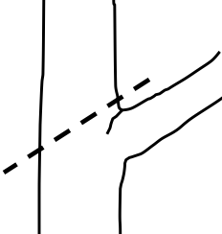
Drop crotch pruning cut at a 45° angle above the branch bark ridge of a branch no less than one-third the size of the cut limb/trunk.

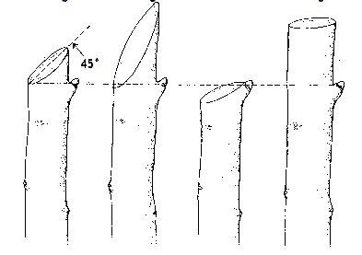
(A) Correct angle and placement of cutting. (B) Too angular. (C) Too low. (D) Too high.

Step 4: Support Tree Health
- Choose an appropriate species
- Water deeply
- Use mulch properly
- Start with a healthy tree
Step 5: Avoid Harmful Practices
- Limit pesticide use
- Avoid high-maintenance non-native trees
Step 6: When to Seek Help
Contact Revelstoke Bear Aware Society
Phone: 250-837-8624
Key Takeaway
If you can’t pick it, don’t grow it.

